**Animations**

**What is an animation?**

**Animation** is where a _ _ _ _ _ _ of still images are _ _ _ _ _ _ together as part of a timed _ _ _ _ _ _ _ _. This makes the _ _ _ _ _ appear to move. This is the same technique used when making _ _ _ _ _ _ _ _.

linked series image sequence cartoons move

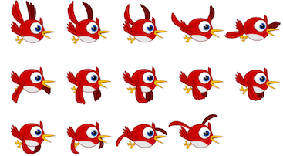

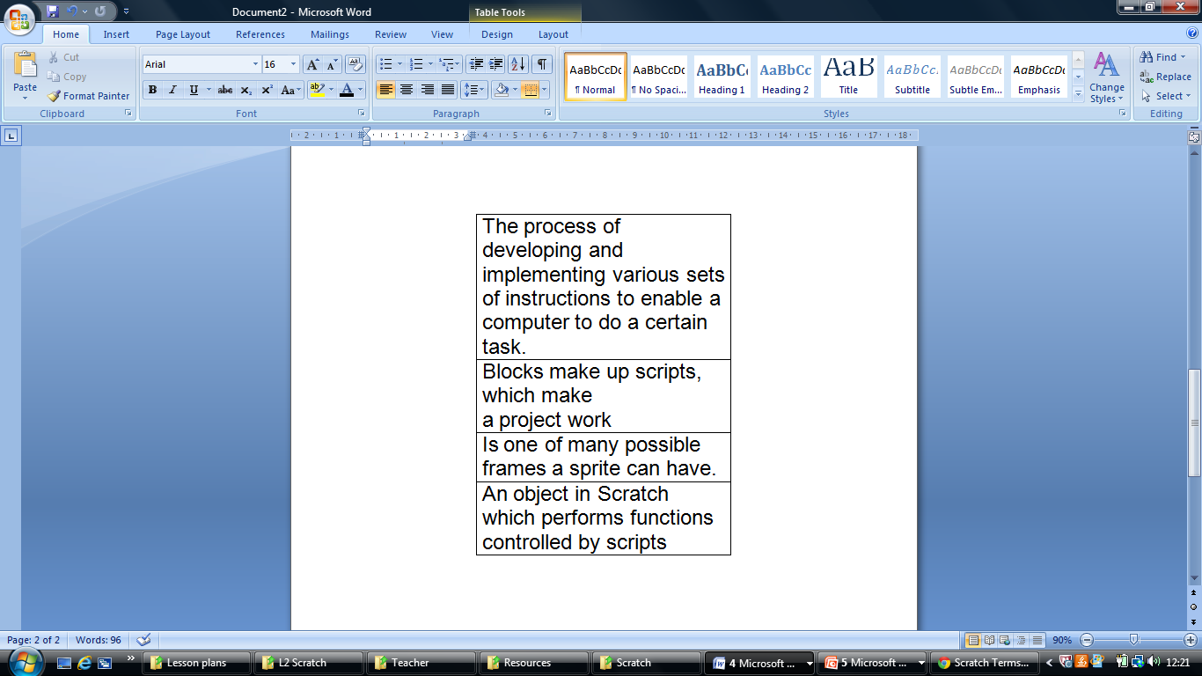Write the term (word) that best fits with each definition.